**How to re-group XML data in RTF Template**

* [3 comments](http://www.adivaconsulting.com/blog-bi-publisher/item/80-rtf-template-working-with-nested-groups.html#itemCommentsAnchor)

Rate this item

* [1](http://www.adivaconsulting.com/bi-publisher/item/80-rtf-template-working-with-nested-groups.html)
* [2](http://www.adivaconsulting.com/bi-publisher/item/80-rtf-template-working-with-nested-groups.html)
* [3](http://www.adivaconsulting.com/bi-publisher/item/80-rtf-template-working-with-nested-groups.html)
* [4](http://www.adivaconsulting.com/bi-publisher/item/80-rtf-template-working-with-nested-groups.html)
* [5](http://www.adivaconsulting.com/bi-publisher/item/80-rtf-template-working-with-nested-groups.html)

(3 votes)

 If we need the grouping, it is always advisable to generate the XML as per the required hierarchy. This makes the RTF design simple and perform better.  But there are situation when we do not have control over XML structure and need to work on flat XML.  Lets see how we can create multiple nested grouping in RTF template.



I am using  following simple flat XML which is generated using scott.emp and scott.dept table.

[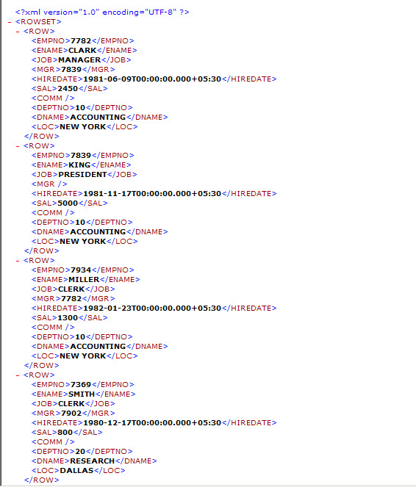](http://www.adivaconsulting.com/images/blog/RTFTemplate_NestedGroups/empxml.jpg)

Lets first design the simple table with default group

[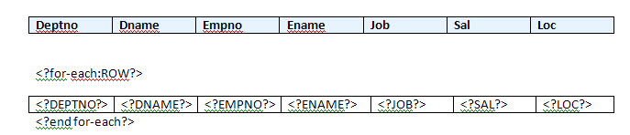](http://www.adivaconsulting.com/images/blog/RTFTemplate_NestedGroups/rtftemplate1.jpg)

It generates simple listing report.

[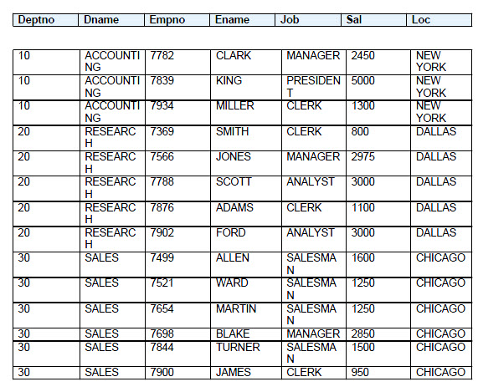](http://www.adivaconsulting.com/images/blog/RTFTemplate_NestedGroups/rtftemplate1a.jpg)

Lest add a group based on Depno. This is achieved by adding following loop

  <?for-each-group:ROW;./DEPTNO?>  --- <?end for-each?> and iterate the detail record within the current group.

[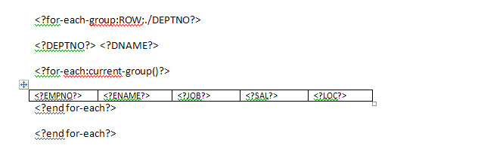](http://www.adivaconsulting.com/images/blog/RTFTemplate_NestedGroups/rtftemplate2a.jpg)

This introduce the Dept Group ..

[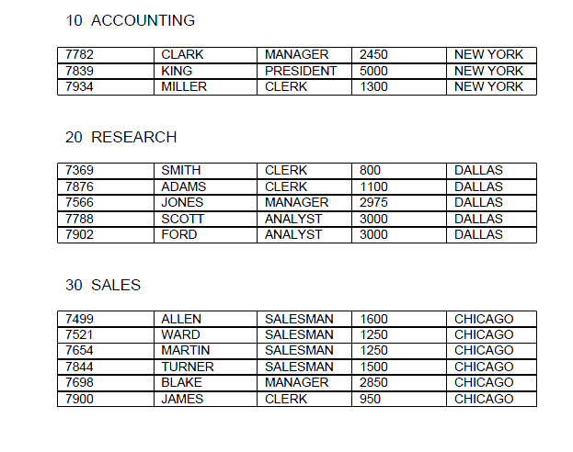](http://www.adivaconsulting.com/images/blog/RTFTemplate_NestedGroups/rtftemplate3.jpg)

Let’s add another nested group for Job within the department group.

[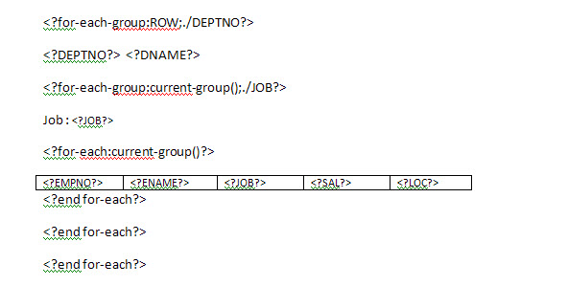](http://www.adivaconsulting.com/images/blog/RTFTemplate_NestedGroups/rtftemplate5.jpg)

[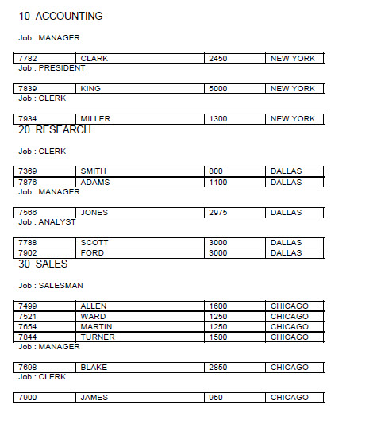](http://www.adivaconsulting.com/images/blog/RTFTemplate_NestedGroups/rtftemplate4.jpg)

Hope this will help to design those nasty nested groups based on flat XML date.